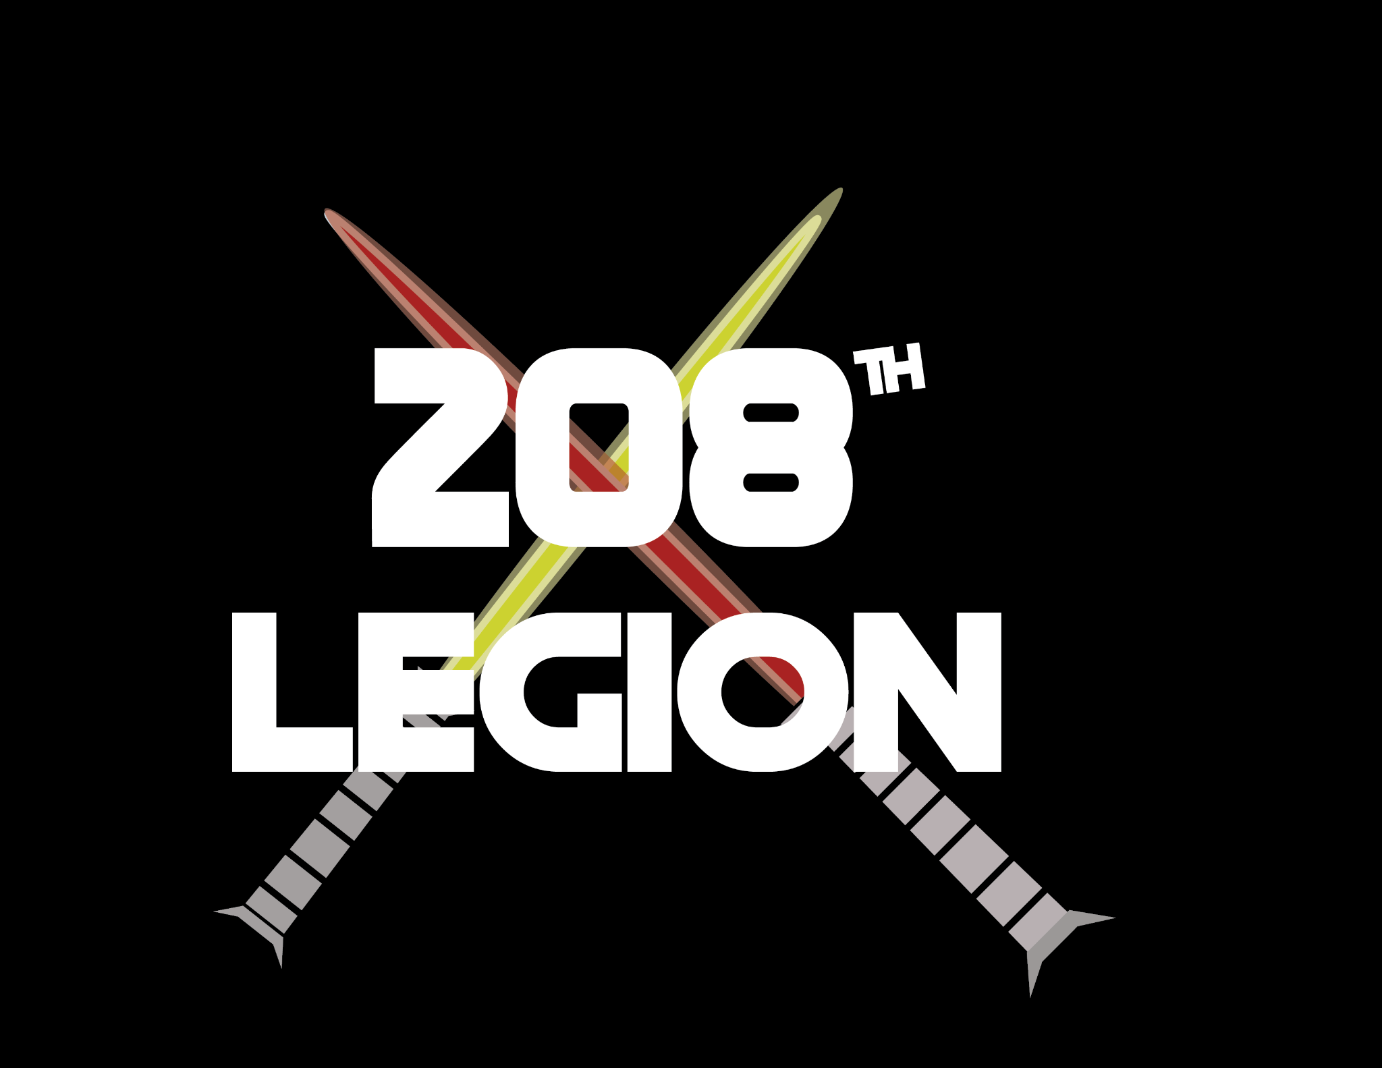

Insert website name here

horizontal line

# A Case For Chad

Who Needs No Introduction

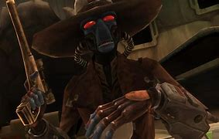

by Darin Erickson on November 20

Cad Bane, otherwise known as Chad Bane, is a spectacle for the seperatist army. With his many abilities and the extra victory point opportunity, he brings to the table a subtler approach of how to win a game of legion.

First, let’s take a look at his unit card!! 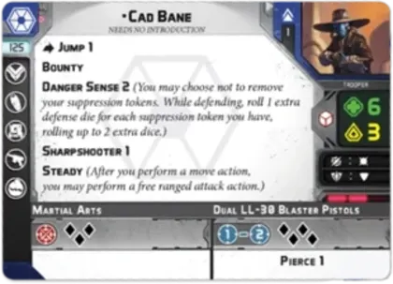

Right off the get go, we see he has action: jump 1, allowing him in the developers words, to keep up with his prey i.e. jedi.

Bounty is the key component to Chad, allowing him to score an extra victory point if he kills the target of his choosing, between commanders and operatives.

Danger Sense 2 is a good sudo impervious if you have suppression on him, but unreliable with his white defense dice.

Sharpshooter 1 and steady are his go to attack amplifiers allowing him to deny light cover and shoot after moving for FREE.

Next his bread and butter, the Command cards.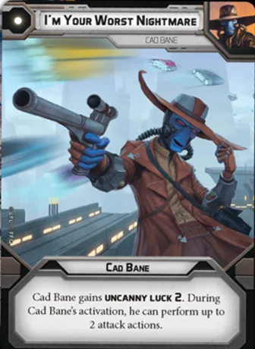

His one pip is a staple to grab if you take him, allowing him to either soften up a target or kill them for the bounty by shooting twice with pierce 1. The Uncanny Luck 2 for the turn just ups his survivability for a bit but it’s surging white die, so not great.

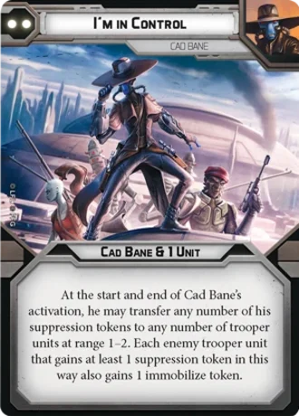

His 2 pip is very much a control piece, allowing you to lock down key pieces of the enemy team while also keeping Cad Bane on the move.

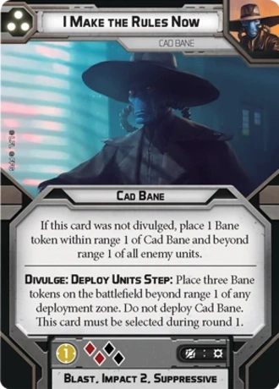

Rules were made to be broken, and in this case, remade again. Cad Bane is impossible to lock down at the beginning of a match because of these Bane Tokens, allowing him to play mind games with your opponent on where he is or where his bomb is. Three tokens, 2 of which are pain if divulged. Other than that, the Chad can do shenanigans with the “Here I am” token allowing him to whisk out to kill or game an objective and then teleport to safety the next round or used as a bomb if you don’t divulge it. The author has won games off of making an opponent confused as to which token is where.

Cad Bane doesn’t need much else so his slots go rather empty.

**List**

Placeholder for lists here

In conclusion, There is always a Case for Chad Bane. Getting an extra victory point on low scoring games can be decisive. He is also a great deterrent to board areas with his tokens and the threat of bounty.

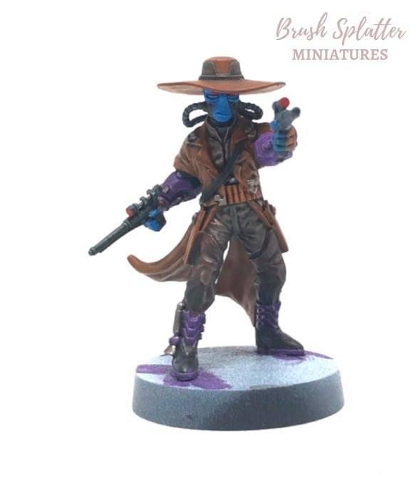

Darin Erickson is a longtime veteran of StarWars Legion and plays often. He loves the bounty hunters and is excited for the Shadow Collective when it comes out. Until then, watch the tables for double bounty and learn to use the dark side of the force.

horizontal line